Career Pages
Main Landing Page

Build Your Career at Rudler CPA
Whether you’re just starting out or looking to take the next step in your career, Rudler, PSC offers opportunities to grow, contribute, and succeed in a supportive and forward-thinking environment.
As a full-service accounting and advisory firm based in Northern Kentucky and serving the Cincinnati region and beyond, we are always looking for motivated individuals who want to make an impact.

Find the Right Path for You

Students & Internships
Start your accounting career with hands-on experience, real client work, and a team invested in your growth. Our internship program is designed to give you the skills and confidence you need to succeed in public accounting.
Link to intern page button -- “Explore Our Students Page”

Experienced Professionals
Take the next step in your career with meaningful work, flexible options, and opportunities for long-term growth. Whether you’re looking for remote, hybrid, or in-office roles, we provide the support and flexibility to help you succeed.
Link to experienced professionals page button -- “Explore Our Professionals Page”

Why Work at Rudler CPA
- Meaningful Work – Build relationships and make an impact with real clients
- Flexible Work Options – Remote, hybrid, and in-office opportunities available nationwide
- Growth & Development – Mentorship, career planning, and ongoing professional development
- Work-Life Balance – PTO structure that rewards your time and supports flexibility
- Supportive Culture – A collaborative team environment that values your ideas and contributions

A Culture That Supports Your Success
At Rudler PSC, we believe our people are our greatest asset. We are committed to creating a workplace that is professional, progressive, and supportive—where individuals are empowered to grow and succeed.
From mentorship and development opportunities to a team-oriented culture, we provide an environment where you can build a meaningful and rewarding career.

Work With Us—From Anywhere
While our firm is based in Northern Kentucky, we proudly hire talented professionals from across the United States. Whether you’re local to the Cincinnati area or seeking a fully remote opportunity, we offer the flexibility to support your career goals.

Ready to Get Started?
Explore our current opportunities and take the next step in your career with Rudler CPA.
👉 View Open Positions

Tab 1 - College Students
Launch Your Accounting Career with Real-World Experience
Start your career with hands-on experience, real client work, and a team invested in helping you grow from day one. Our accounting internship program, based in Northern Kentucky, serves students from the Cincinnati area and surrounding communities and is designed for college students seeking real-world experience in public accounting.
Button -- View Internship Opportunities

What to Expect from Our Accounting Internship Program
- Real-World Experience – Work on real client projects that build practical, career-ready skills
- On-the-Job Training – Learn by doing with hands-on training and guidance from experienced professionals
- Team Environment – Collaborate with a supportive team that values learning and open communication
- Advanced Technology – Use modern tools and software that reflect today’s accounting industry
- Work & School Balance – Balance your academic commitments with a flexible and supportive work schedule
- Engaging Workplace Culture – From games and giveaways to catered meals and team events, we make work a place you’ll actually enjoy being—alongside our unofficial mascot, Rudsley the pig

(example of format)
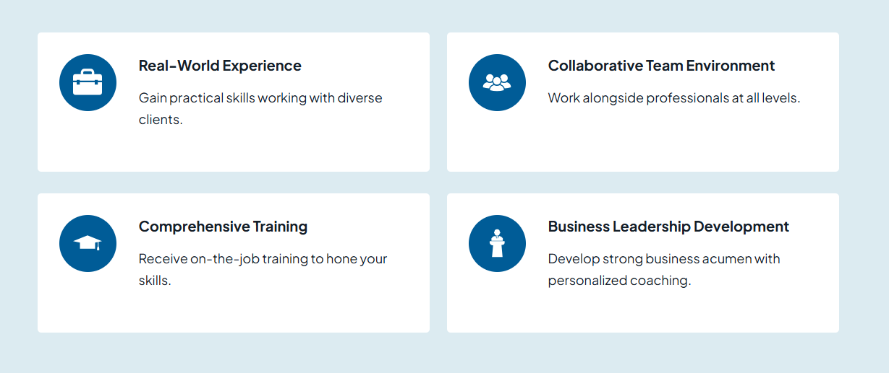

Meet Rudsley, Our Mascot
At Rudler, even our culture has personality. Our unofficial mascot, Rudsley the pig, started as part of a 2021 stuffed animal drive and quickly became a team favorite. His name was chosen through a company-wide vote, and as a nod to “piggy banks,” he’s a fun reminder of the work we do every day.
(Insert photo of Rudsley here)

More About Our Internship Program
Our interns don’t just sit back and observe—they contribute to real client work with the support and guidance of experienced professionals. We take pride in a culture that is both professional and progressive, while still knowing how to have fun. Interns are fully immersed in our environment and have the opportunity to participate in activities like bingo, company celebrations, ticket raffles, community volunteering, and more.
Each intern is assigned a personalized learning plan that includes recorded webinars, podcasts, and other resources to support their development throughout the internship. In addition, interns participate in a two-week, in-person training program led by our team, helping them build a strong foundation from day one.
While not guaranteed, many of our interns continue with us beyond the initial timeframe—most commonly after tax season—and transition into extended internships or full-time opportunities. In fact, many of our full-time team members began their careers here as interns.
As a full-service accounting firm, we also provide opportunities for extended interns and full-time team members to gain exposure across multiple departments, helping them discover the path that best fits their career goals.

Benefits & Perks

Core Benefits
- Professional Development Support – Gain access to training and learning opportunities (including CPA-related education, known as CPE) to support your long-term career growth
- Competitive Compensation – Opportunities for raises and bonuses for extended interns

Additional Perks
- Cell Phone Reimbursement – Helping you stay connected and productive
- Employee Committees – Opportunities to get involved and shape our workplace culture (available to extended interns)
- Team Activities & Book Clubs – Building connections beyond the day-to-day work

Bottom page – testimonials “ What our interns say about us”

Tab 2 – Experienced Professionals

Advance Your Accounting Career with a Firm That Invests in You
Take the next step in your career with meaningful client work, growth opportunities, and a team that supports your long-term success. At Rudler, PSC, we offer accounting careers in Northern Kentucky and the Cincinnati area, as well as opportunities for professionals across the country.
With flexible work options—including remote, hybrid, and in-office roles—we welcome candidates both locally and nationwide who are looking to grow in public accounting.
Button --- “View Career Opportunities”

What to Expect from Your Career at Rudler, PSC
- Meaningful Client Work – Work directly with clients on impactful projects
- Professional Growth & Development – Ongoing talent development meetings, mentorship, and opportunities to expand your skills
- Collaborative Team Environment – A supportive culture that values communication, connection, and shared success
(example of format)


Benefits & Perks

Core Benefits
- Competitive Compensation – Annual raises and performance-based bonuses
- Flexible Work Options – Remote, hybrid, and in-office opportunities available nationwide
- Work-Life Balance – PTO structure where hours worked over 40 convert into additional time off
- Professional Development Support – CPE courses covered, with training time considered chargeable
- Retirement & Profit Sharing – 401(k) plan with profit-sharing opportunities

Additional Perks
- Wellness & Gym Reimbursement – Supporting your physical and mental well-being
- Cell Phone Reimbursement – Helping you stay connected and productive
- Employee Committees – Opportunities to get involved and shape our workplace culture
- Team Activities & Book Clubs – Building connections beyond the day-to-day work

Why Experienced Professionals Choose Rudler, PSC
Experienced accounting professionals choose Rudler, PSC because we offer more than just a role—we offer a place to build a long-term, fulfilling career.

More Than Just a Job
At Rudler, you’re not siloed into tasks—you’re building relationships, contributing ideas, and making a real impact on clients and the firm.

Flexibility Without Sacrifice
We offer flexible work options while maintaining a collaborative, connected team environment—something many firms struggle to balance.

A Firm That Invests in You
Your growth isn’t an afterthought. Through mentorship, development conversations, and diverse experience, you have the support to shape your career.

A Culture of Trust and Respect
We value your experience and empower you to take ownership of your work, contribute ideas, and collaborate across all levels.

Stability with Forward Momentum
With over 50 years of history and a forward-thinking approach, we combine a strong foundation with a focus on the future.

Build a Career, Not Just a Job
At Rudler CPA, our professionals don’t just complete tasks—they build relationships, solve problems, and make a meaningful impact for our clients. You’ll work alongside a collaborative team that values your input and supports your growth every step of the way.

Opportunities for Growth and Advancement
We believe in investing in our people for the long term. Through mentorship, ongoing development conversations, and exposure to a variety of service areas, our team members can expand their skills and shape their career paths.
Whether you’re looking to deepen your expertise or explore new areas within public accounting, we provide the support to help you get there.

Accounting Careers in Northern Kentucky & Cincinnati
Our firm is based in Northern Kentucky and serves clients throughout the Cincinnati region and beyond, offering opportunities for professionals seeking a firm that values flexibility, growth, and a strong team culture.

Work With Us—From Anywhere
While our firm is based in Northern Kentucky, we proudly hire talented accounting professionals from across the United States. Whether you’re local to the Cincinnati area or seeking a fully remote opportunity, we provide the flexibility and support to help you succeed from wherever you are.

Bottom page – testimonials with pictures “ What Our Team Says”

Example was DeanDorton
Also liked the presentation of the awards.

